Introduction
The IoT-Based Smart Stick for Blind Persons is an innovative assistive device designed to enhance safety and independence for visually impaired individuals. It uses an ultrasonic sensor to detect nearby obstacles, a flame sensor to identify fire hazards, and an ESP32 microcontroller to process inputs and trigger outputs. Alerts are given through a buzzer and a vibration motor for real-time feedback. Additionally, a Pushbullet API integration enables the stick to send emergency notifications to caregivers via the internet. This project combines embedded systems, IoT, and sensor technology to create a practical, low-cost solution that addresses real-world accessibility challenges.

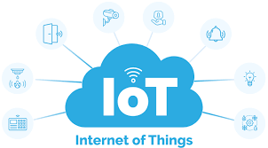

Smart Stick for Blind Persons in Assistive Technology
The Smart Stick for Blind Persons is a significant advancement in the field of assistive technology, which focuses on developing tools and devices to enhance the quality of life for people with disabilities. This intelligent stick is specifically designed to help visually impaired individuals navigate their surroundings safely and independently.

Components Used:

1. Ultrasonic Sensor (e.g., HC-SR04)
- Use Case: Detects obstacles in front of the user by measuring distance using ultrasonic waves.
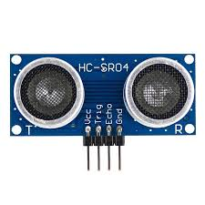
- Properties:
  - Range: 2 cm to 400 cm
  - Accuracy: ±3 mm
  - Operating Voltage: 5V
- Other Applications:
  - Robot navigation
  - Industrial automation

2. Flame Sensor (IR Flame Detection Module)
- Use Case: Detects infrared light from flame sources to alert the user about fire hazards.
- Properties:
  - Detection Range: 0–100 cm (varies by flame size and sensitivity)
  - Wavelength: Sensitive to 760 nm to 1100 nm
  - Operating Voltage: 3.3V – 5V
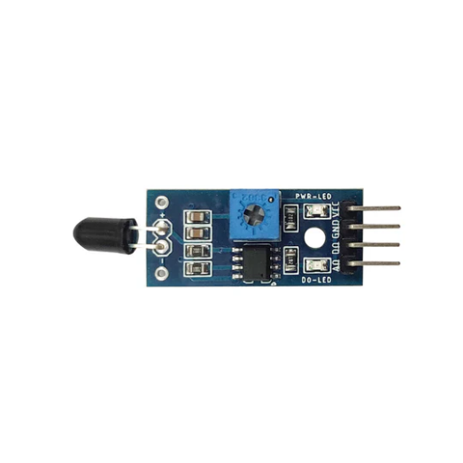
- Other Applications:
  - Fire alarm systems
  - Safety systems in kitchens or factories
  - Smart home fire monitoring

3. ESP32 Microcontroller
- Use Case: Central processing unit; reads sensor inputs and controls output devices, and handles Wi-Fi-based Pushbullet communication.
- Properties:
  - Dual-core 32-bit processor
  - Built-in Wi-Fi and Bluetooth
  - Operating Voltage: 3.3V
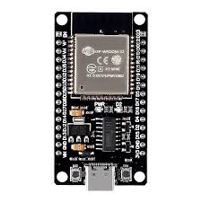

- Other Applications:
  - Home automation
  - IoT-based weather stations
  - Smart agriculture systems

4. Vibration Motor (Mini ERM Vibration Motor)
- Use Case: Provides tactile feedback (vibration) to notify the user of obstacles or danger.
- Properties:
  - Voltage: 3V – 5V
  - Speed: 9000–14000 RPM
  - 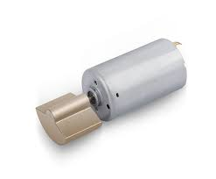:

5. Buzzer (Piezoelectric Buzzer)
- Use Case: Generates an audio alert when an obstacle or flame is detected.
- Properties:
  - Voltage: 3V – 12V
  - Frequency: ~2 kHz
  - Current: 10–30 mA
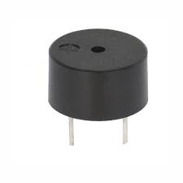
- Other Applications:
  - Alarm systems
  - Timers and buzzers in electronic devices
  - Notification systems in embedded devices

6. Pushbullet API
- Use Case: Sends real-time emergency messages to smartphones or web browsers via the internet.
- Properties:
  - Supports text, links, images
  - Cross-platform (Android, iOS, web)
  - Requires internet access via ESP32

- Other Applications:
  - IoT alert systems
  - Home security notifications
  - Smart doorbell notifications
  - Task automation with IFTTT or Zapier

7. Emergency Button (Tactile Push Button)
- Use Case: Allows the user to manually trigger emergency alerts when in distress.
- Properties:
  - Type: Normally Open (NO)
  - Operating Voltage: Compatible with 3.3V/5V logic
  - Debounce required in software
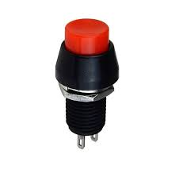
- Other Applications:
  - Panic alert systems
  - Machine start/stop control
  - DIY electronics and robotics

Circuit Diagram:
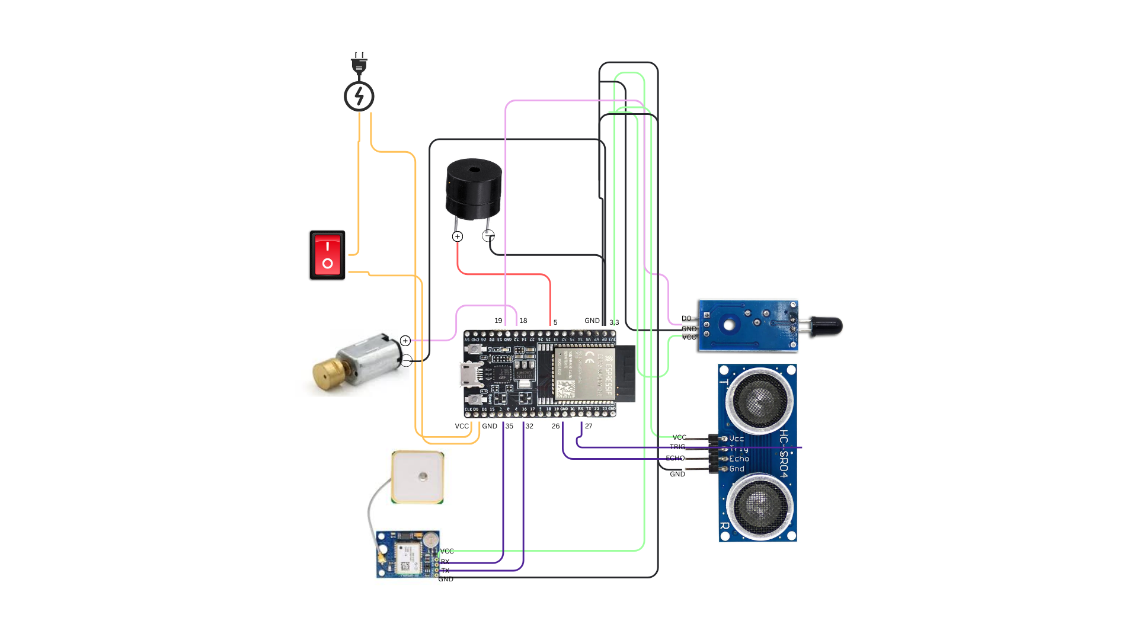

✅ Advantages of the Smart Stick
- Enhanced Safety
  - Detects obstacles and fire hazards in advance, reducing the risk of accidents.
- Real-Time Alerts
  - Provides instant feedback through buzzer and vibration, ensuring the user is constantly aware of their environment.
- Emergency Communication
  - Sends alert messages to caregivers using the Pushbullet API, offering peace of mind and immediate support during emergencies.
- Increased Independence
  - Enables visually impaired individuals to move around confidently without constant assistance.
- Compact and Lightweight
  - Easy to carry, user-friendly, and doesn’t require any special training.
- Low Power Consumption
  - Efficiently designed to run on small batteries, suitable for daily usage.
- Affordable and DIY-Friendly
  - Uses low-cost components, making it a budget-friendly and replicable project for students and NGOs.
- Smart Navigation
  - Can detect objects that are out of reach of a traditional white cane, including above-ground obstacles.
- Customizable
  - Can be enhanced with features like GPS, voice output, or mobile app integration as future upgrades.

⚠️ Limitations of the Smart Stick
- Limited Obstacle Detection Range
  - The ultrasonic sensor has a range of about 2–4 meters, which may not detect far or fast-approaching objects in time.
- No Voice Assistance
  - Without voice feedback, some users may find it difficult to interpret buzzer/vibration signals in complex environments.
- Battery Dependency
  - The device depends on a continuous power supply; battery drainage can render it non-functional without warning.
- Weather Sensitivity
  - Sensors may not perform optimally in extreme weather conditions like heavy rain, fog, or intense sunlight.
- Limited Flame Detection
  - Flame sensors detect only open flames within a short distance and may miss smoke or heat from covered sources.
- No GPS Navigation
  - The stick doesn’t include GPS for location tracking or pathfinding in unfamiliar areas (can be added as an upgrade).
- Wi-Fi Dependency for Alerts
  - Pushbullet messages require active Wi-Fi; in its absence, emergency notifications won’t work.
- Lack of Terrain Feedback
  - Cannot detect changes in terrain like stairs, slopes, potholes, or puddles effectively.

🚀 Future Scope of the Smart Stick
- GPS & Navigation Integration
  - Adding GPS and Google Maps API support to provide route guidance and location tracking for outdoor navigation.
- Voice Feedback System
  - Integrating a speaker or voice module to give verbal alerts (e.g., “Obstacle ahead”, “Fire detected”) for better understanding.
- Mobile App Connectivity
  - Developing a dedicated mobile app to configure sensitivity levels, track location, and monitor battery status.
- Obstacle Classification using AI
  - Using cameras and AI to recognize and classify obstacles (like humans, walls, vehicles) for smarter assistance.
- Fall Detection System
  - Adding an accelerometer to detect if the user has fallen, triggering automatic alerts to emergency contacts.
- Water/Weather Resistance
  - Improving the hardware casing to make the device waterproof and more durable in extreme weather conditions.
- Rechargeable Battery with Solar Panel
  - Using a solar-powered rechargeable battery to increase portability and reduce the need for frequent charging.
- Terrain Detection
  - Adding IR or LiDAR sensors to detect uneven surfaces, stairs, and ground-level changes.
- Obstacle Mapping & Cloud Storage

Conclusion
The IoT-Based Smart Stick for Blind Persons is a practical and impactful assistive device that significantly improves the mobility, safety, and independence of visually impaired individuals. By integrating sensors like ultrasonic and flame detectors with ESP32, buzzer, and vibration motor, the stick provides real-time obstacle and hazard alerts. The inclusion of Pushbullet API for emergency messaging adds an extra layer of protection and connectivity. This micro project not only demonstrates the application of embedded systems and IoT in solving real-life problems but also promotes the development of affordable and accessible technology for differently-abled communities.

